**Department**

**for International**

**Development**



Single Departmental Plan - Results Achieved by Sector in 2015-2020

**Jobs and income**

**Number of people supported to have raised incomes and better jobs or livelihoods**

**1. Results**

**From 2015/16 to 2019/20 DFID supported 5.1 million people to raise their incomes or maintain/gain a better job or livelihood.[1]**

* 1. **Results by gender**

99% of results were broken down by gender. Of the 5.1 million people supported, 3.6 million were men and 1.5 million were women (figures do not sum due to rounding).

* 1. **Results by Region**

Figure 1: People supported by region

Figures rounded to the nearest 100,000

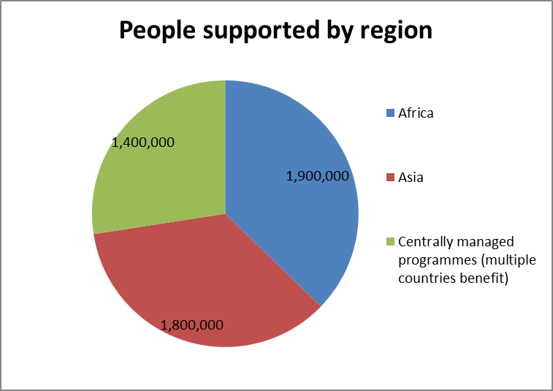

* 1. **Results by indicator type[2]**

Of the total 5.1 million people supported to raise their incomes or maintain/gain a better job or livelihood:

* 2.4 million people were supported to raise their income.
* 1.9 million people were supported to gain or maintain a better job or livelihood. This includes figures for programmes which measured the number of jobs created/maintained, rather than have indicators which directly measure beneficiary numbers. However a single beneficiary is assumed for every job maintained/created.
* The remaining 0.7 million people were beneficiaries for programmes where the indicator measured the total of all or some of the following.
* maintained income
* increased income
* maintained employment
* gained employment
* jobs created
* jobs supported.

These results were not possible to further disaggregate from data held centrally.

The change from previous year in the total number of people supported is affected by the composition of programmes reporting, as well as by previously reporting programmes reporting new results. Each year new programmes may start reporting results eligible for inclusion in this indicator.

One significant change this year is that we have included CDC results for the first time. CDC accounted for 0.85m people supported[3] (of which 72% Male, 28% female). Only beneficiary figures for 2018 (not for every year) have been included for CDC in the 2015/16 to 2019/20 DFID results, this is to avoid double counting the same beneficiaries who may appear in figures for multiple years otherwise. Note that CDC also reports indirect employment beneficiaries in supply chains, induced from wages, and enabled by productivity improvements from credit and power, estimated from the Joint Impact Model which are not included in DFID’s aggregate figures.

**2. Context**

DFID’s overarching priority in economic development is to promote growth that creates more and better[4] productive jobs and livelihoods to help people lift themselves out of poverty. Enhanced employment opportunities and skills is also a means to address the underlying drivers of instability and can support longer term security and stability.

**3. Methodology summary[5]**

Results have been collected from 30 programmes within DFID. These programmes all:

* Focused on job rich activities with an objective to either increase beneficiaries’ income from economic activity or get beneficiaries into more productive and/or better quality employment, and can provide a clear rationale of why and how the programme is doing this.

and

* The relevant jobs/income related effects on beneficiaries are monitored at least twice within the lifetime of the programme (e.g. within the logframe or regular surveys) within the existing monitoring

The exact definition of jobs/incomes is not stipulated for inclusion for this indicator as this will legitimately vary across countries, sectors and over time. In addition, the most suitable job/income indicator for programme monitoring will need to be programme-specific to maximise its value for monitoring. Following good monitoring practices, we expect indicators to be aligned with programme objectives.

These programmes incorporate a range of indicators. The majority were analysing whether incomes have increased, but indicators monitoring number of jobs supported/created were also included.

Where indicators were monitoring numbers of jobs rather than people a 1:1 assumption is made for people supported per job. This is likely conservative estimate as 1 FTE job on average will support more than one person.

Figures do not take into account beneficiaries of programmes who have been supported through income multiplier effects. Such excluded effects are known as induced effects. Those who benefit from these income multiplier/induced effects have their income raised when those who have more directly benefitted from the programme spend their income. Previously we described these effects as “indirect” but we are changing our terminology to “induced” to bring our definitions into line with other donors and multilaterals.

Where programmes are not solely DFID funded, total programme results with regard to the number of people supported are adjusted for the percentage of funding DFID provided.

DFID can be said to support these beneficiaries in that there have been observed changes in these beneficiaries’ job status or income, or there have been observed changes in outputs which have a credible modelled link to changes in incomes or job status, for example they have been provided with cheaper agricultural inputs such as seed. The figures cannot be fully attributed to DFID in that this is a monitoring metric and in most cases programmes have not used counterfactuals to adjust for other factors which could have caused changes in beneficiaries’ income or job status.

**4. Data sources**

Data are collected from monthly, quarterly and annual results reports from partners, mid-year reviews, annual reviews and project completion reports.

Original data sources are administrative or surveys. This includes surveys of individuals, households and businesses.

**5. Data quality notes and reporting lags**

Data which is survey based has been reported as based on a representative sample. There will be significant variance across the programmes’ reporting however.

1. This figure represents the sum of an annual flow of people for the years 2015/16, 2016/17, 2017/18,2018/19 and 2019/20.
2. Figures rounded to nearest 100,000
3. CDC numbers are in full-time equivalents, as per the HIPSO definition, and so are underestimates of individual beneficiaries eg seasonal and part time workers
4. Better jobs imply higher productivity and earnings, better benefits, better working conditions, and/or improved income protection, for example.
5. https://www.gov.uk/government/publications/dfid-results-methodology-notes-2018-to-2019